**American International University – Bangladesh**



Faculty of Science and Technology

Department of Computer Science

CSC 3224: Computer Graphics

Project Report

|  |  |
| --- | --- |
| ***Course Name*** | Computer Graphic |
| ***Section*** | H |
| ***Course Teacher*** | Aneem Al Ahsan Rupai |

|  |  |
| --- | --- |
| ***Group Member*** | ***ID*** |
| Rahman, Mushfiqur | 19-399841 |
| Ekra, Nusrat Jahan | 19-401561 |
| Tuli, Anamika Sarkar | 19-40222-1 |
| Islam, Hasibul | 20-42865-1 |

***Table of Contents :***

|  |
| --- |
| ***Content List*** |
| Introduction |
| Background |
| Objective of the project |
| System Implementation |
| Significant of the Project |
| Conclusion |

***Introduction:***

The project we have done is about “Village Scenario”. In this project we have used a lot of objects. Some of those objects are with animation and there are also some objects those don’t have any animation. But every objects in this scenario have their own Specific ID as per the instrusctions of our project.

***Background:***

Computer graphics is responsible for displaying art and image data effectively and meaningfully to the consumer. It is also used for processing image data received from the physical world, such as photo and video content.

There are two types of computer graphics: raster graphics, where each pixel is separetly defined (as a digital photograph), and bector graphics, where mathematical formulas are used to draw lines and shapes

OpenGL is a software interface to graphics hardware. It considers points, lines, polugons, images and bitmaps to be primitives. The latest version supported for OpenGL is 4.1 from 2011. OpenGL is a cross- language, cross-platform graphics API for rendering 2D and 3D scenes

Using a graphics card. 2D and 3D refer to the actual dimensions in a

computer workspace. 2D is "flat", using the horizontal and vertical (X and Y)

dimensions. 3D adds the depth (Z) dimension. This third dimension allows for rotation and visualization from multiple perspectives.

***Object:***

In project we use many object.These object are below here:

* Sky
* Sun
* Birds
* Clouds
* Moon
* Star
* Some flowes
* Kite
* Grass
* Trees
* Hills
* Some Buildings
* Some people
* Flag
* Road
* Train
* Some others vehicle
* River
* Boats

***System Implementation:***

* OpenGL
* CodeBlocks

***Feature:***

There are some feature.These feature are given below here:

**In Day Mode[Press B]:**

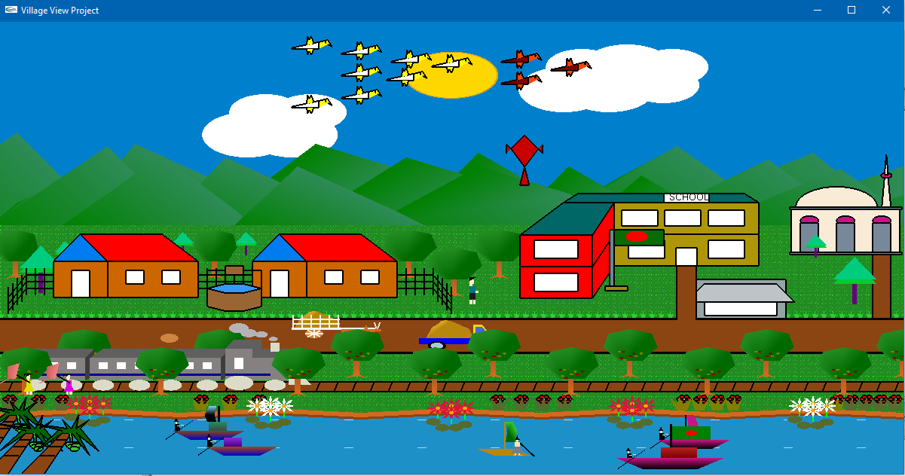

**In Night Mode[Press N]:**

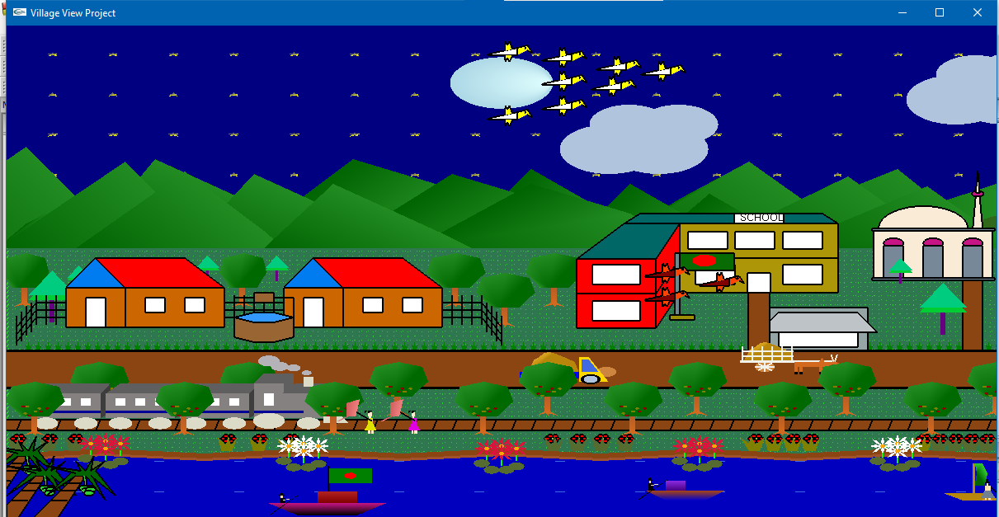

**In Raniy Day/Night Mode[Press R]:**

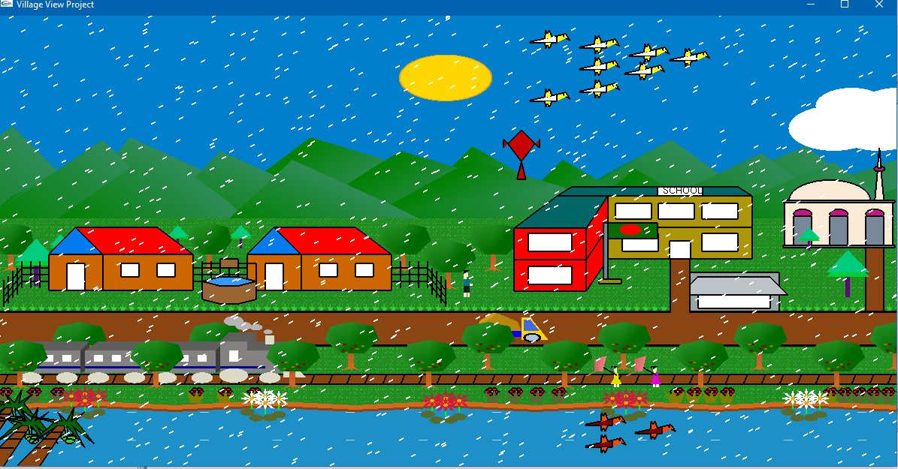

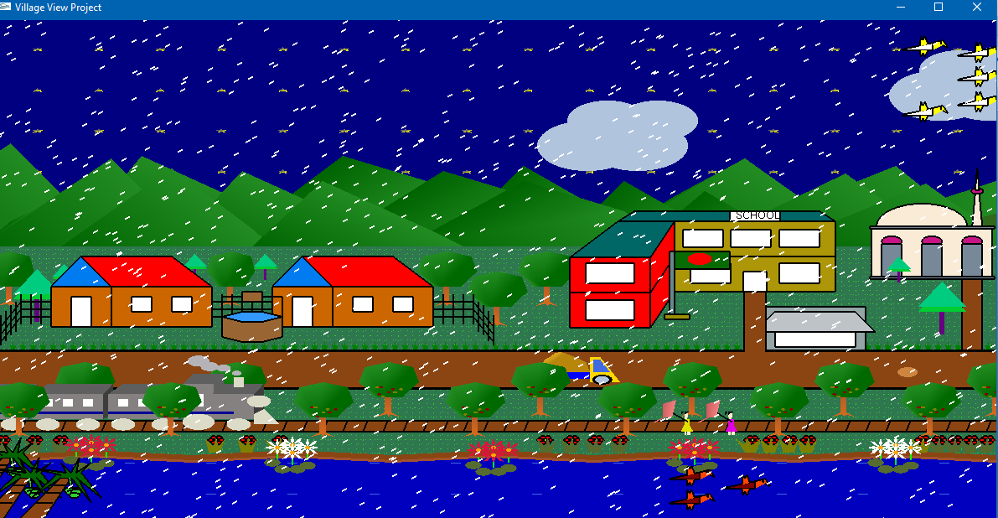

**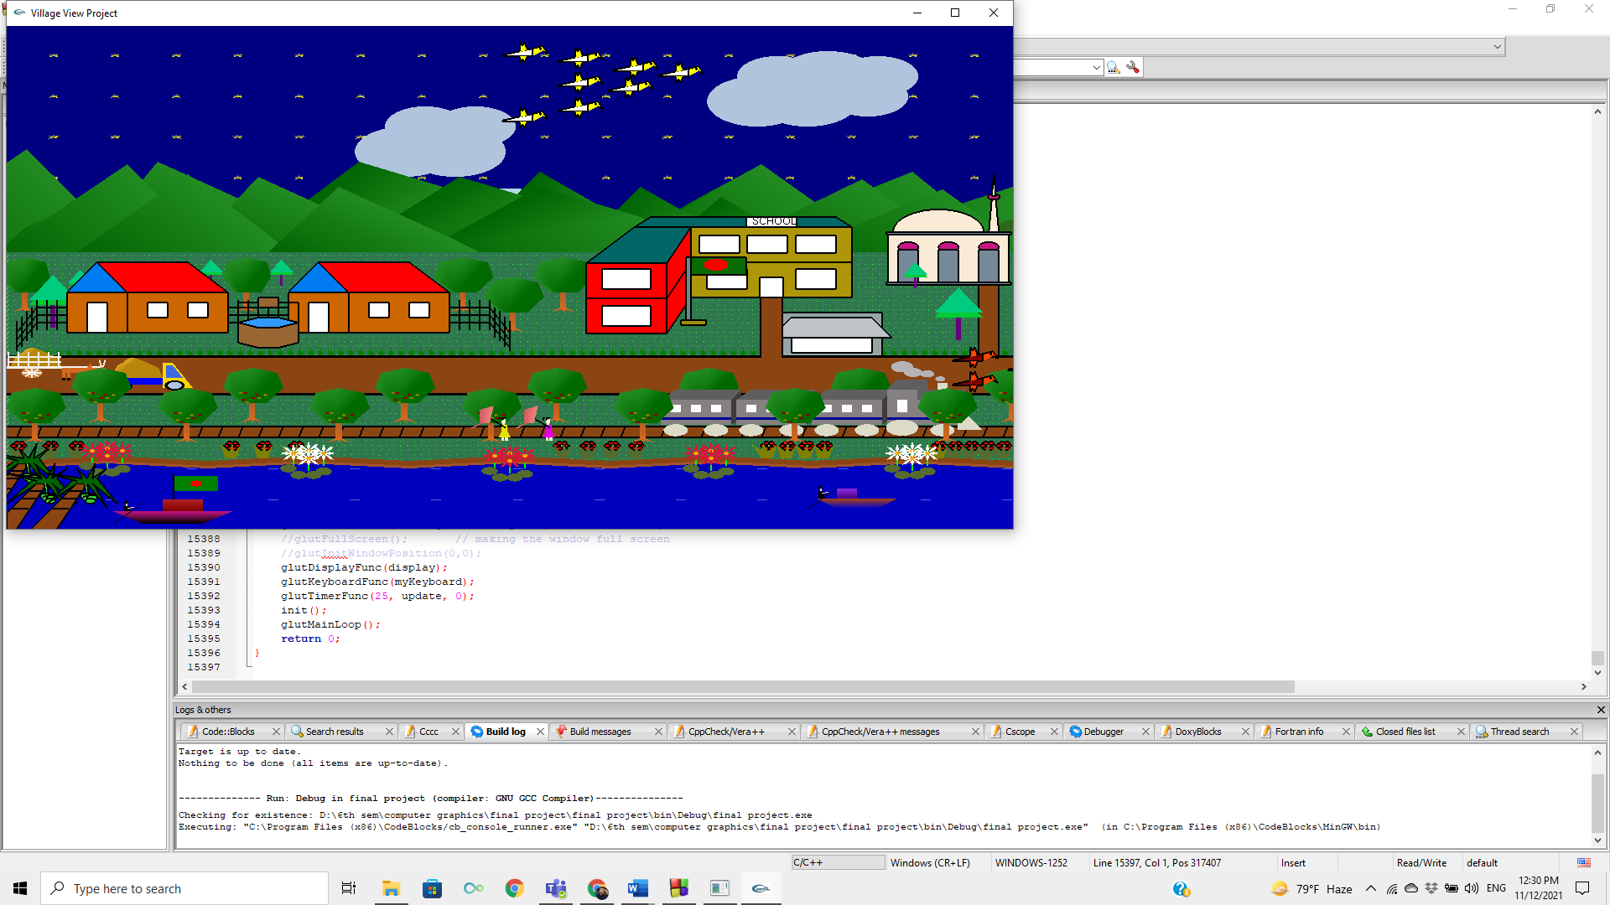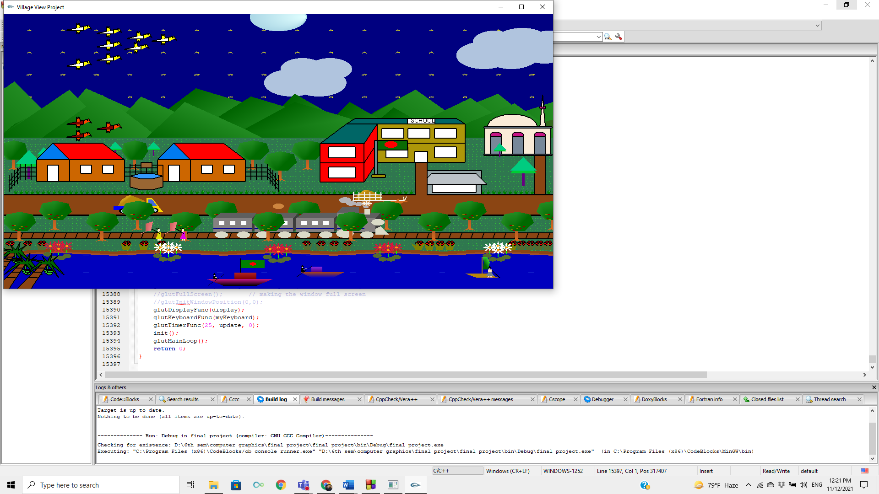****To move train forward[Press D]**

**To move train Backword[Press A]**

***Significant of the project:***

Computer Graphics is the change of Visual and geometric information using computational techniques, typography, photography, iconography and illustration. The project which we select is to give visual of "Village Scenrio". Through the process we also got to know how we can easily make a 2D animation come to life with use of proper animation,features and colors.

This project includes a lot of options in it. By doing this project we can understand how to design structure sky clouds and many more. We have given you the idea to implement the simple objects as we have used in this project you can also develop simple objects to this project and it will look even better. For the future implementations try to create a road and some vehicles moving in the road and etc.

***Conclusion:***

We have implemented a view of village. We have shown using

code blocks(version 17.12) and different functionalities where day night and

evening view appears through keyboard interaction. We have used both

keyboard (d,n,e) appears through keyboard interaction to change the view.

We implemented the color of the object by the following RGB colour code.

The program runs everything perfectly as we planned I n future we would

like to develop this project into a 3D architecture